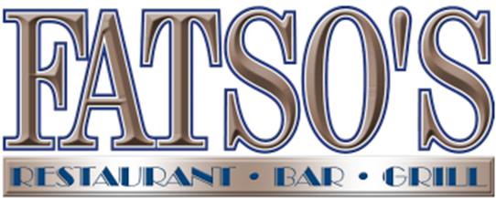
Date:
Time:
Number in Party:
Booking Name:
Contact Number:
Email:

107 Salhouse Road, Sprowston, Norwich NR7 9AW
sprowston@fatsos.net
Menus can be found at: www.fatsos.net
In order to give you the best dining experience, please ensure your party arrives for the time booked. During our busiest time we allow a 2-hour table time for all parties after which you are welcome to continue your evening in our bar. If this does not suit your requirements, please telephone our manager to discuss other arrangements.
Please email your completed pre-order form to your chosen restaurant: Sprowston - sprowston@fatsos.net

 | NAME | STARTER |  | MAIN |  | POTATO OR RICE CHOICE |  | STEAK COOKING CHOICE | SIDE ORDERS |  | NOTES |  | DESSERT
1
2
3
4
5
6
7
8
9
10
11
12
13
14
15
16
17
18
Potato Choice: |  |  | F = Fries |  | C = Curlies |  | W = Wedges |  |  | JP = Jacket Potato |  | R = Spicy Rice
Upgrade: |  |  | LCF = Loaded Cheesy Fries |  | CBF = Cheesy Bacon Fries |  | HLCF = Hot Loaded Cheesy Fries |  |  | Also available as  Curlies
Detailed allergen information can be found on our website however is subject to change. Please refer to our allergen information at the time of your visit.
If you have any special dietary requirements or food allergies, please clearly make note on the form, and speak to a manager on arrival.

